**Human-Computer Interaction**

Challenge 3 – CA3

Nicolas D’Alessandro Calderon

**Outline and competencies C3**

### Graded assignment

| **Start** | **Deadline** | **Grade** | **Time** |
| --- | --- | --- | --- |
| **18/03/25** | **14/04/25** | **28/04/25** | **43h** |

### Have you ever thought about measuring whether an interface works well or not? In this practical challenge, we will learn to use some tools to obtain qualitative and quantitative data in order to evaluate the current state of an interface

### Related competencies and Learning outcomes

| **Related competencies** | **Learning outcomes** |
| --- | --- |
| **Transmit information, ideas, problems and solutions to both a specialized and non-specialized audience;** | * Explain the different user profiles participating in the project * List the different elements to improve |
| **Summarize, interpret, present and critically contrast the results obtained using the most appropriate analysis and visualization tools.** | * Identify different platforms or systems similar to the one presented. * Reflect on the operation of systems similar to the given case study. * Summarize the strengths and weaknesses in different platforms, systems or services. |
| **Analyze, conceptualize, design and evaluate interaction processes and their interfaces in the field of HCI.** | * Analyze how the fundamental concepts are applied to the case study |

**Table of Contents**

**Case Study** 2

**Introduction for the assignment C2** 4

**Instructions for the assignment C2** 6

**Answers for the assignment C2** 9

1️⃣ Flowchart 9

2️⃣ User Testing 15

3️⃣ Universal Design Principles 37

4️⃣ First Version of the Prototype 45

## **Case Study**

## 📱🚍 Accessible Public Transport Apps 🌍♿

Nowadays, mobile public transport applications are key tools for planning routes, checking schedules, and ensuring efficient mobility. Examples like **Moovit, Citymapper, and Google Maps** allow millions of users to find real-time transport options. However, for people with **visual or motor disabilities**, these applications present challenges regarding **accessibility, usability, and customization**.

Some of the most common difficulties include the **lack of customizable options in the interface, unclear information about accessible routes, and intrusive notifications**. These barriers limit user confidence and experience when interacting with these applications, reducing their effectiveness and accessibility.

**How can we optimize the user experience in public transport applications to make them more inclusive, accessible, and valuable for people with visual or motor disabilities?**

To address the challenges posed throughout the semester, you must use the provided application examples, as they are specifically designed for this type of service. **You must work only with the examples from this case study, as PECs based on other examples or cases will not be accepted.** Below are examples of public transport applications:

* **Moovit**: A platform that allows users to plan public transport routes.  
  **URL**: [https://moovitapp.com](https://moovitapp.com/)  
  **Free version**: It includes essential features such as route planning and real-time schedules.
* **Citymapper**: Provides detailed multimodal route information with advanced options for public transport, cycling, and walking.  
  **URL**: [https://citymapper.com](https://citymapper.com/)  
  **Free version**: Yes, it includes interactive maps and basic planning options.
* **Google Maps**: A tool with public transport information, directions, and interactive maps.  
  **URL**: [https://maps.google.com](https://maps.google.com/)  
  **Free version**: It includes access to all main features.

### Project Development

Throughout the semester, the mentioned applications will be analyzed, and you will develop your **inclusive public transport application prototype**, applying **Human-Computer Interaction (HCI), User-Centered Design (UCD), and Universal Design (UD) principles**. To effectively achieve this, consider the following **five requirements**:

1. **Interface Customization**: Allow accessibility adjustments such as **high-contrast mode, screen reader support, and text size adjustments** to enhance the experience for low-vision users.
2. **Accessible Route Planning**: Implement filters that prioritize **routes with accessible features**, such as **functional elevators and ramps**, while avoiding **paths that include stairs**.
3. **Interactive Navigation**: Provide **step-by-step navigation with multimodal options (visual, auditory, and haptic)** adapted to each user's capabilities.
4. **Configurable Alerts**: Offer **customizable notifications** to alert users about **route changes, out-of-service access points, and other relevant incidents** tailored to individual preferences.
5. **User Feedback**: Include a feature that allows users to **evaluate route accessibility and generate reports** that can be shared with authorities or developers for future improvements.

With these requirements in mind, your **accessible public transport application prototype** aims to **overcome the most common barriers** faced by users, particularly those with **accessibility needs**, when interacting with these platforms. By applying **Human-Computer Interaction (HCI) principles**, the goal is to create an **optimized user experience** that ensures an **intuitive, efficient, and inclusive** design, facilitating **mobility and autonomy** for all users.

## **Introduction for the assignment C2**

📍 DEFINITION

#### After completing the **research**stage in our User-Centered Design (UCD) methodology, it's time to move on to the second challenge, where our focus will be on **defining the proposal for the interface**. In this stage, we will apply key methods to ensure that our design is both functional and intuitive. First, we will use **flowcharts** to understand the user journey. Then, we will conduct tests with users who meet the profiles we have previously defined. These 2 methods allow us to obtain direct feedback and understand how users interact with the applications in our [**case study**](https://aula.uoc.edu/courses/50236/pages/case-study).

#### In addition, we will incorporate the **principles of universal design**, aiming to create an interface that is accessible and usable for the widest possible range of users, regardless of their abilities or limitations. And finally, this stage will culminate with the creation of the**first version of our prototype**, where we begin to bring to life the ideas and findings obtained so far, all these pieces will come together to form an initial design solution that will then be refined.

**1. Flowchart**

[**Flowchart**](http://human-computer-interaction.aula.uoc.edu/flowchart/)in Human-Computer Interaction (HCI) are crucial visual tools that represent the sequence of steps and decisions in a user's interaction with a system or application. These diagrams provide a clear and structured view of how users navigate and perform tasks, helping to identify potential friction points or inefficiencies. By visualizing the flow of the user experience, the interface can be optimized for more intuitive and efficient navigation, which is essential for creating digital products that are easy to use and meet users' needs and expectations.

💡Consult the [**Flowchart Guide**](https://human-computer-interaction.aula.uoc.edu/guia/flowchart/)**.**

💡Example of [**Flowchart**](https://aula.uoc.edu/courses/50236/files/6247736?wrap=1)

**2. User Testing**

[**User testing**](https://human-computer-interaction.aula.uoc.edu/user-testing/) is essential in the design and development of products, as it provides an understanding of the user's needs and behaviors. Through this evaluation, usability problems that are not evident to designers are identified, allowing for adjustments that significantly improve the user experience. This process validates design assumptions, reduces long-term development costs, and increases user satisfaction and loyalty, ensuring that the final product is not only functional but also intuitive and appealing to the user.

💡Consult the [**User testing Guide**](https://human-computer-interaction.aula.uoc.edu/guia/user-testing-guide/)**.**

💡Example of [**User Testing**](https://aula.uoc.edu/courses/50236/files/6247734?wrap=1)

**3. Universal Design Principles**

[**Universal design**](https://human-computer-interaction.aula.uoc.edu/accessibility/) is an inclusive approach in creating products and environments that aim to be accessible and usable by all people, without the need for adaptations or specialized designs. It focuses on creating solutions that cater to the widest possible range of abilities, ages, and other user characteristics, ensuring equality of access and user experience. This approach not only improves accessibility for people with disabilities but also benefits the general population, promoting the creation of more functional and versatile products. Nowadays, universal design is particularly relevant for the development of technologies and web applications that are inclusive and accessible to everyone.

💡Ckeck in W3C [AccessibilityLinks to an external site.](https://www.w3.org/WAI/fundamentals/accessibility-intro/)

💡Universal Design [example](https://aula.uoc.edu/courses/50236/files/6247726?wrap=1).

**4. First Version of the Prototype**

This first version of the [**prototype**](https://human-computer-interaction.aula.uoc.edu/prototyping/) provides a tangible validation of the initial ideas and concepts. Put the first ideas of your prototype into practice by integrating the results you have obtained by applying the different techniques from challenges 1 and 2. The objective is for you to start representing with generic components the elements of the interface of your proposed solution.

💡Consult the [**Prototyping Guide**](https://human-computer-interaction.aula.uoc.edu/guia/prototyping/)

💡Prototype[**example**](https://aula.uoc.edu/courses/50236/files/6247730?wrap=1)

## **Instructions for the assignment C2**

📍 DEFINITION

In this **Definition**stage: Synthesis of the Proposal of our User-Centered Design (UCD) process, it is now time to focus on how our ideas begin to take shape, concentrating on shaping the interface of our **prototype**. To do this, we will use four key methods: the creation of **flowcharts**to map the user path, **tests**with real **users**to obtain direct feedback, the application of **universal design principles** to ensure accessibility and inclusion, and finally, we will develop the **first version of our prototype.**

**1. Flowchart**

👉 Create flowcharts for **two (2) of the**[**case study**](https://aula.uoc.edu/courses/50236/pages/case-study)**requirements** that you find most interesting.

⚠️ For each [**flowchart**](http://human-computer-interaction.aula.uoc.edu/flowchart/):

* Define all steps textually.
* Appropriately use each figure of the diagram: diamonds, squares, and circles.
* Connect the steps with arrows.

⚠️ Once you have the diagrams, analyze them and answer the following questions for each one:

* How many steps do you have to take to complete each diagram and how much time do you invest?
* Is there only one way to complete the task?
* What points are the most problematic in your opinion?
* What points are the clearest in your opinion?

**2. User Testing**

👉 Apply the [**User testing**](https://human-computer-interaction.aula.uoc.edu/user-testing/) technique:

* Select **one (1) reference application**from the [**case study**](https://aula.uoc.edu/courses/50236/pages/case-study).
* Contact **two (2) users** interested in the theme of our case study who match the characteristics of the user profiles defined in Challenge 1 (they can be friends, family, colleagues, etc.).
* Choose **two (2) requirements from the**[**case study**](https://aula.uoc.edu/courses/50236/pages/case-study) and define 3 tasks for each.

⚠️ In the report, you must include:

* Description of the users (at least **two (2) users** = **one (1) from each profile**)
* Script of the session (**three (3) tasks** for each of the **two (2) requirements**)
* Results of the interview
* Analysis and reflection on the interviews
* Proposal for improvements

#### **3. Universal Design Principles**

👉 Analyze the applicability of the **seven (7)**[**design for all**](https://human-computer-interaction.aula.uoc.edu/accessibility/)**principles**to evaluate the applications of the case study. For this, exemplify each of the principles by adding a screenshot and justify their applicability. (**It is not necessary for all 7 principles to apply to a single application**. If you prefer, you can use examples from other apps or websites you use for this type of service).

#### **4. First Version of the Prototype**

👉 Propose the solution for **dos (2) requirements** of the [**case study**](https://aula.uoc.edu/courses/50236/pages/case-study), for this, distribute the information in the user interfaces you need to resolve the requirement.

👉 Considering the principles of universal design, explain and draw how it is possible to **incorporate in your solution proposal** the **criteria of equal use and error tolerance**.

### **5. Reflections**

👉 To conclude the **definition phase**, it is essential to reflect on the **lessons learned** and how the activities carried out in this stage helped shape your proposal and prepare you for the next steps. Select **one (1)** of the reflection questions below and record a **video of up to 3 minutes** with your response.

### How did creating flowcharts influence your understanding of user navigation?

### What observation during user testing surprised you the most, and how did it impact your design?

### When applying universal design principles, which one do you consider has the greatest impact on the application's accessibility?

### What challenges did you face when developing the first version of your prototype, and how did you solve them?

### If you were to repeat this stage, how could you improve the clarity of the flows or the quality of the initial prototype?

### **Deliverables**

To complete the submission of this activity, please attach the final document to the **Delivery activity C2**. The format of your **document must be PDF and uncompressed, and the video must be in .mp4** format. This will ensure that the content remains **accessible** and maintains its **original format**, making it easier to review.

⚠️ **Remember to verify that all elements of your work are included and displayed correctly in the document before uploading it.**

### **Assessment and evaluation criteria**

The evaluation will take into account the presentation of the document, as well as its structure (cover, index of contents, development of the answers), legibility (adequate font for reading and body size of 12 points) and organization (numbered pages, heading with the name of the student and the degree course). Writing, clarity, expression and spelling will be valued.

✏️ As for the evaluation criteria for each of the tasks, they are described in the [**Challenge 2 rubric.**](https://aula.uoc.edu/courses/50236/assignments/585930)

**IMPORTANT**

In this activity, only limited use of artificial intelligence tools is permitted. Specifically, in a UX design project, AI tools, both textual and visual, can be used to generate and sketch ideas, contextualize concepts, propose prototypes, or combine elements in an innovative or alternative way. If these tools are used, **it is necessary to explicitly and correctly cite the use of AI tools** in the work's development. This includes: indicating in the submission which **tools** have been used in each section of the activity, the **objectives**, the **prompts** that have been used, the **response** obtained, and the process followed to **review and edit the output**. To do this correctly, consult the guide [How should we cite AI in our works?](https://openaccess.uoc.edu/bitstream/10609/148823/1/U2_17_GuiaCitarIA_CAT.pdf) Information on what is considered irregular conduct and its consequences can be found in the teaching plan and on the [UOC's website about academic integrity and plagiarism](https://campus.uoc.edu/estudiant/microsites/plagi/en/index.html). Remember that when using generative AI tools, personal, confidential, or intellectually protected information must not be provided.

Bear in mind that improper use of generative AI, such as not reviewing the obtained response or failing to cite the used tools, will be considered irregular conduct in the assessment. In case of doubt, consult with the teaching staff.

## **Answers for the assignment C2**

## 1️⃣ Flowchart

## 1️⃣. 1️⃣ Requirement Chosen I

**“Accessible Route Planning:** Implement filters that prioritize routes with accessible features, such as functional elevators and ramps, while avoiding paths that include stairs.”

For this requirement, I will propose the following process:

* **Start**: The user opens the app.
* **Open the route planning interface:** The user navigates to the route planning section (usually the homepage by default). The app shows the page for planning a route.
* **Enter origin and destination points**: The user enters the name of the place they want to go from and to. *Example: from “Terrassa Rambla” to “Plaza de Catalunya”*
* **Configure accessibility filters**: In this step the user will select the filters to apply in the search. *Example: “no stairs”, “elevator”, etc.*
* **Search Routes:** The user clicks the “Search” button to find routes.
* **Accessible routes found?** The app checks if exists any routes that meet the selected criteria:
  + If **not**, the user decides whether to Exit the app and end the flow or try different options and return to Configure accessibility filters Example: unchecking “no stairs”, etc.
  + If **yes**, the user proceeds to **View Route Options** and check the details of each route found.
* **Suitable route found?** After checking details, the user decides if any option works for them.
  + If **not,** the user decides whether to **Exit the app** and end the flowor **try different options** and return to **Configure accessibility filters** *Example: unchecking “no stairs”, etc.*
  + If **yes**, the user proceeds to **Choose the best route** by selecting their preferred option. *Example: Selecting the second option with less transfers.*
* **Start Navigation?** The user decides whether **to being the guided navigation** ending the flow or continue viewing options for planning the route.

**Start**

Enter Origin and Destination points

Open the route planning interface

Configure accessibility filters

Search routes

**Accessible**

**routes found?**

**Yes**

**No**

Exit the app

**Suitable**

**route found?**

**Yes**

**No**

Choose best route

**Start**

**Navigation?**

Check detailed route information

**No**

**End**

**Try different options?**

**Yes**

**No**

**End**

Begin guided navigation

**Yes**

There are around 10 steps to complete the diagram, depending on the chosen flow. If everything goes well, it will take around 1 or 2 minutes to complete, but how clear the user is on what they want will of course influence the total time.

There are several ways to complete the task:

* Find a suitable route in the first try.
* Try different accessibility options and combinations until find a suitable route.
* Check the route details and go back to try different accessibility filter combination options.
* Exit the application without finding any route that satisfies the user’s needs.

The most problematic points are:

* **Accessibility routes found** because if no routes exist the user may feel frustrated.
* The **Configure accessibility filters** because users may not know exactly what filters they need.
* **Suitable route found** because reading the route details can be difficult for some people.

The clearest points are:

* **Enter origin and Destination points** because most users will understand this point easily.
* **Choosing the best route** is also easy when the information displayed is clear.
* Finally, **Start Navigation** and **Exit the app** will be very straightforward options for most of the users.

## 1️⃣. 2️⃣ Requirement Chosen II

**“****Configurable Alerts:** Offer customizable notifications to alert users about route changes, out-of-service access points, and other relevant incidents tailored to individual preferences.”

For this requirement, I will propose the following process:

* **Start**: The user opens the app
* **Open Alert Settings interface:** The user navigates to the Alert Settings view.
* **Check current alert configuration:** The user checks the already configured alert types and preferences.
* **Modify alerts configuration?** User decides if the current alert configuration is ok or if any modification is needed.
  + If **not,** the alerts configuration remains ending the flow.
  + If **yes**, the user continues the flow to configure the alerts configuration.
* **Set Alert Types categories**: The user select which types of alerts to receive. *Example: “Route Changes”, “Service Disruptions”, etc.*
* **Set Notification Method preferences:** The user selects how to receive these alerts. *Example: “Visual”, “Audio”, “Alert Frequency”, etc.*
* Test alert settings? User decides whether to test the notification configuration:
  + If **not**, it moves to **save the alerts configuration preferences**.
  + If **yes**, the user continues to test the notification.
* **Send test notification**: The user clicks the button to send a sample alert.
* **Verify test alert**: The user checks the test alert behavior. *Example: Check if the alert sounds as expected, etc.*
* **Test alert result works?** The user decides if the alert works as expected.
  + If **not,** the user returns to **adjust the alerts settings.**
  + **If yes,** the user proceeds to **save the alerts settings.**
* **Save alert configuration?** The user decides whether to save the configured alerts settings.
  + If **not**, the user will **Discard all changes** and end the flow.
  + If **yes**, proceed to **Confirm and activate**, setting the alerts preferences and ending the flow.

**`**

Set Alert Types categories

Open Alert Settings interface

**Start**

Set Notification Method preferences

**Save alert configuration?**

**Yes**

**No**

**Test alert settings?**

**Yes**

**No**

Verify test alert

Send test notification

**Test alert result works?**

**Yes**

**No**

**End**

Confirm and activate alerts

Discard all changes

**End**

Check current alert configuration

**Modify alerts configuration?**

**Yes**

**No**

**End**

Keep current alerts configuration

There are around 11 steps in the flowchart, depending on the chosen flow. It will take around 3 to 5 minutes to complete the process, especially if the user tests the alerts.

There are several ways to complete the task:

* + - A quick path if the user checks the current settings, no changes needed and the flow ends.
    - A basic path where the user checks the current settings, modifies and saves.
    - A complete path where the user checks the current settings, sets the preferences, tests the notification, verify and save.

The most problematic points are:

* + - The **Set alert types categories** may be difficult if there are many options.
    - The **Set notification method preferences,** because the user may struggle to set the right method.
    - The **Verify the test results,** because the user might not know what to look for when verifying.

The clearest points are:

* + - The **Open alert settings interface,** because it is a simple entry point to the notification settings.
    - The **Check the current alert configuration,** part, because it is easy to understand what is already set.
    - The **Save alert configuration,** because it is a simple yes/no decision.

## 2️⃣ User Testing

2️⃣.1️⃣ Task Approach

For this user testing exercise, I have selected the **Google Maps** application since it is widely used, and it offers a lot of opportunities for improvement in many of the accessibility features in comparison with the other two apps. The main objective was to understand how easy or difficult it is to use this public transport app specially for users with disabilities in the selected requirements.

I selected the same two requirements from the previous exercise **Accessible route planning** and **Configurable alerts** to keep consistency along all this practice for achieving the best prototype design in exercise 4.

For each requirement I implemented three specific tasks that will allow users to interact with the application and provide insights into potential usability barriers.

Due to the challenge of finding actual users matching the defined accessibility profiles, **I conducted one complete real test with a family member with hearing impairment and one simulated disability user test with another family member**. To mimic realistic conditions within the visual impairment, I followed the strategy described by the professor and implemented a workaround. For **visual impairment** simulation, I used dark sunglasses and on top some ski glasses that significantly reduce the visibility and clarity, representing the conditions for a user with low vision.

Finally, to make the user testing exercise easier, I **created two simple online forms** where the users could share their experiences after completing the tasks and report any problem if they found. This helped me to collect feedback in one place for the final analysis. Even both users understand basic English for interpreting the questions, we allow answers in Spanish their native language, to be able to collect more valuable feedback.

2️⃣.3️⃣ Description of the Users

**Behaviours**

**Psychographics**

**Needs & Goals**



**BENITO** is a 65-year-old retired Physical Education teacher who lives in Mutxamel, a suburban town near Alicante. He has three adult sons and enjoys spending time outside.

Benito has a hearing impairment and uses a hearing aid, but his condition has not improved significantly, which makes it hard for him to understand spoken instructions or audio notifications.

He has low tech skills and often needs assistance when setting up new applications. He values simple and accessible features that require minimal effort to use.

* Large buttons and reduced typing.
* Easy instructions.
* Alerts that don’t require fast interaction.
* Minimalistic screens and easy-to-understand design.
* Uses basic phone and apps with assistance.
* Avoids typing and prefers one-click interactions.
* Use public transportation occasionally for sporadic appointments.
* Relies on clear symbols and minimal steps
* Values simplicity and practicality.
* Avoids complicated interfaces.
* Prefers traditional ways and he is always very reluctant to learn new technologies.



* Clear audio descriptions and voice alerts.
* Easy-to-navigate interfaces.
* Real-time transport updates.
* Simple and effective accessibility settings.
* Values independence and safety.
* Prefers simple technology.
* Enjoys structure and routine.
* Uses high-contrast modes and large text on devices.
* Prefers voice feedback for interacting with apps.
* Plans trips carefully and in advance.
* Travels mostly during daytime.

**LORENA** is a 47-year-old Administrative Assistant who lives in Terrassa, a city near Barcelona. She has three children: one adult son (27) and two younger kids aged 12 and 8.

She often uses public transport to move around the city.

**Lorena has a visual impairmen**t and uses screen magnifiers, voice feedback, and large text settings on her phone.

Her tech skills are medium, and she can navigate apps with some support. She prefers simple interfaces with high contrast and clear feedback.

**Behaviours**

**Psychographics**

**Needs & Goals**

2️⃣.4️⃣ Requirement and Task Proposed

1. **Introduction**

Hello, and thank you for participating in this user testing session!

Before we begin, I want to highlight that we are testing the application and not you. There are no right or wrong answers, and your honest feedback is extremely valuable to us. This session will help us understand how to improve public transportation applications to make them more accessible and user-friendly.

This session will take approximately 45-50 minutes, you only need to complete a few tasks using the Google Maps application and then complete the survey.

**Preliminary Questions**

First, I'd like to ask you a few simple questions:

1. Name______________________________________________________
2. Age: __________________________________________________________
3. Occupation: ____________________________________________________
4. Device Type: ___________________________________________________
5. Operating System: ______________________________________________
6. Do you have any disabilities or impairments that affect how you use mobile applications? (Optional)___________________________________________
7. How would you rate your comfort level with technology on a scale of 1-5, with 5 being very comfortable? _________________________________________
8. How often do you use public transportation? __________________________
9. Have you used any public transportation mobile applications before? If yes, which ones? ___________________________________________________
10. **Test Case A - Accessible Route Planning**

**Proposed Scenario**

“You want to visit a friend who lives in the city center for a coffee. You require wheelchair accessibility and would like to find a route that meets your needs.”

**Tasks to attempt:**

**Task 1**

Open Google Maps and search for a route from your home location to the city center. Look for the wheelchair accessible routes option and enable it.

**Task 2**

Explore the accessible route information provided and check if it includes details about elevator availability, ramps, or other accessibility features.

**Task 3**

Look at the different route options, select the one that seems most accessible and then start the navigation.

**Survey**

1. Were you able to find the accessibility options for route planning?

* Yes, easily
* Yes, but it took some time
* No, I couldn't find them

2. How easy was it to find the wheelchair accessible route option in Google Maps?

* Very easy
* Moderately easy
* Difficult
* Very difficult

3. What specific accessibility information was provided about the route? (select all that apply)

* Wheelchair accessible routes
* Routes with elevators
* Routes avoiding stairs
* None of these

4. How clear was the information provided about route accessibility?

* Very clear
* Somewhat clear
* Not clear at all
* No accessibility information was provided

5. Were you able to find and use the "Report an accessibility issue" feature?

* Yes, easily
* Yes, but it was difficult
* No, I couldn't compare them

6. Did the app provide information about accessible entrances or facilities at your destination?

* Yes, detailed information
* Yes, but limited information
* No information provided

7. How would you rate the process of reporting an accessibility issue?

* Simple and straightforward
* Moderately easy
* Difficult or confusing
* N/A - Couldn't find the feature

8. What accessibility barriers did you encounter during this task? (select all that apply)

* Text too small or hard to read
* Poor contrast between elements
* Buttons or touch targets too small
* Complex navigation or too many steps
* None

**Extra Question:**

What improvements would you suggest for the accessible route planning feature? ___________________________________________________________________

______________________________________________________________________________________________________________________________________

1. **Test Case B - Configurable Alerts**

**Proposed Scenario**

“You use Google Maps regularly for your commute. You want to stay informed about transit updates, especially those that can affect accessibility, like elevator maintenance or service changes.”

**Tasks to attempt:**

**Task 1**

Open Google Maps and try to find where to turn on notifications related to public transport.

**Task 2**

Search for a train or metro station and check if you can find real-time accessibility information alerts or notifications like elevators or step-free access.

**Task 3**

Plan a trip using public transport and try to save the route. Check if there is any way to get updates or alerts for this route.

**Survey**

1. Were you able to find where to configure public transport notifications?

* Yes, easily
* Yes, but with difficulty
* No, I couldn't find them

2. Which of these alert types were you able to configure? (select all that apply)

* Route changes
* Elevator outages
* Service disruptions
* Accessibility-related alerts
* None of these
* N/A - I couldn't find any information

3. Could you customize how you receive alerts? (select all that apply)

* Visual notifications
* Sound alerts
* Vibration/haptic feedback
* Alert frequency options
* No customization options found

4. Could you find a way to get alerts for transit delays or service issues on a specific route?

* Yes, easily configured
* Partially – found some options but not complete
* No, couldn’t find this option

5. Was the notifications information easy to read and understand?

* Yes, very accessible
* Somewhat accessible
* Not accessible enough
* N/A – didn’t find any transit info

6. How useful were the updates or notifications for someone with accessibility needs?

* Very helpful
* Somewhat helpful
* Not helpful
* N/A – couldn’t find updates

7. What accessibility barriers did you encounter when trying to configure alerts? (select all that apply)

* Difficult to find alert settings
* Complex or confusing interface
* Text too small or hard to read
* Limited alert options
* None

**Extra Question:**

What improvements would you suggest for configurable alerts and transit updates to better serve users with accessibility needs?_________________________________

______________________________________________________________________________________________________________________________________

1. **Overall Feedback**

1. Based on your experience, how would you rate Google Maps for accessibility on a scale of 1-5?

* 1 - Poor
* 2 - Fair
* 3 - Average
* 4 - Good
* 5 – Excellent

2. What was the most difficult aspect of using Google Maps? __________________

___________________________________________________________________

3. What features would you like to see added to make Google Maps more accessible? _________________________________________________________

___________________________________________________________________

2️⃣.5️⃣ Test Results

**User 1: Benito**

**User 2: Lorena**

2️⃣.6️⃣ Analysis and reflection

**Overall Assessment:**

Based on the user testing conducted with both participants, **we can conclude that Google maps have a lot of space for improvement in the accessibility area**. The testing, despite being conducted with a reduced audience, was expected to reveal strengths and weaknesses but mainly revealed only weaknesses in the approach to accessibility, particularly for users with disabilities.

**Key findings:**

***Test Case 1: Accessibility Route Planning***

* Both users find it difficult to find the wheelchair accessible option. Even Lorena with moderate high tech-skills, declared to find it “moderately easy” after considerable effort.
* The information provided about accessibility was declared “not clear at all” by Benito and “somewhat clear for Lorena”. This was partially affected by the fact that in Mutxamel, where Benito search for routes, there are poor accessibility conditions in public transportation and the Google Maps app did not show the accessibility options filter information when the route has not these options.
* None of the users was able to find the “Report and accessibility issue feature”, which was expected but still concerning since this feedback mechanism is crucial to improve accessibility information over time.
* Regarding the specific impairments, Lorena finds some difficulties with some important text information such as the disclaimer on the veracity of accessibility information, which is essential for clear communication for users relying on the app.

***Test Case 2: Configurable Alerts***

* The results of this test were the most revealing given that none of the users could find the notification configuration. Even though it was expected when designing the test case to receive poor results in this feature given the lack of configurable options, the fact that even Lorena with his moderate high technology skills didn’t find the option for activate notification, really raises the concern about interface usability.
* On top of these barriers, the customization options about alerts for users with sensory impairments were spotted as null.
* The analysis of this feature based on the results is very limited, since none of the users pass the first stage.

**Common Barriers:**

* Text size and readability were marked as barrier, especially by Lorena with visual impairment.
* The complex navigation and structure of the interfaces.
* The notification system is the clearest pain-point being particularly insufficient for accessibility needs.

**Conclusion:**

This test revealed that Google Maps, despite being the most widely used app worldwide, really fails in providing accessible public transport features, particularly for users with disabilities.

The major barrier was not the information but how it is communicated and presented to the user. Both users struggle to find the information or even the options to activate it. The findings highlight a clear need for improvement in both discovering accessible features and comprehension of the information provided.

Finally, we will remark that the exercise demonstrates the critical importance of the user testing to gather information and understand or uncover accessibility issues that might not be apparent. However, the sample of two users will not be sufficient to a real world understanding of the situation.

2️⃣.7️⃣ Proposal for improvements

Based on the results of the user testing analysis I will propose the following improvement to enhance accessibility in the Google Maps app:

**For Accessible Route Planning:**

1. **Simplify Accessibility Filter Panel:** Relocate the accessibility options to a more visible position in the main interface.
2. **Improve the communication mechanisms of the Accessibility Information**: Include visual indicators like icons for accessibility features like elevators, ramps, etc.
3. **Simplify the Reporting Mechanism**: Add a clear visible “Report Accessibility Issue” button with the route view.

**For Configurable Alerts:**

1. **Simplify Alerts and Notifications panel:** Relocate the activate alerts option to a more visible position in the main interface.
2. **Testable Alerts**: Make alert configuration testable in the configuration screen.
3. **Notification features**: Add the possibility to configure how to receive the notifications (audio, visual, haptic feedback, etc.)

I will attempt to add all these proposals to our prototype interface in exercise 4.

## 3️⃣ Universal Design Principles

3️⃣.1️⃣ Equitable use

In this case I have selected the example of **Google Maps which offers a “wheelchair accessible” option for routes**. This means that when this filter is selected, the app will show results of routes that only include stations or vehicles with ramps and elevators (no stairs).

Similarly, we can find the same **filter for accessibility routes in the Moovit app**, allowing for getting results of accessible public transportation routes.

This feature makes the app **equitable** because people with mobility disabilities can plan their route like any other user.

*Google Maps:*

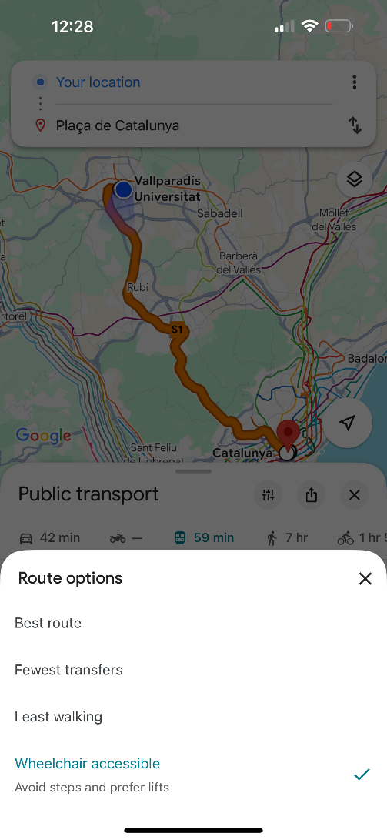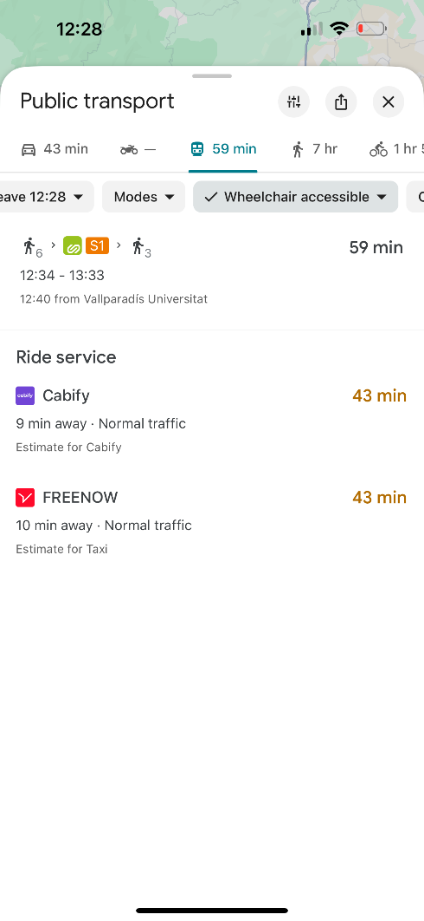

*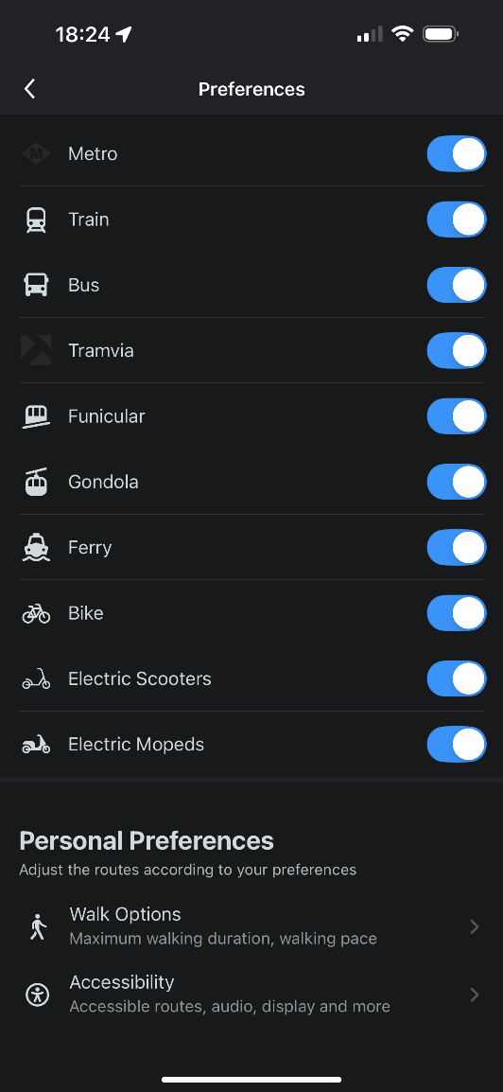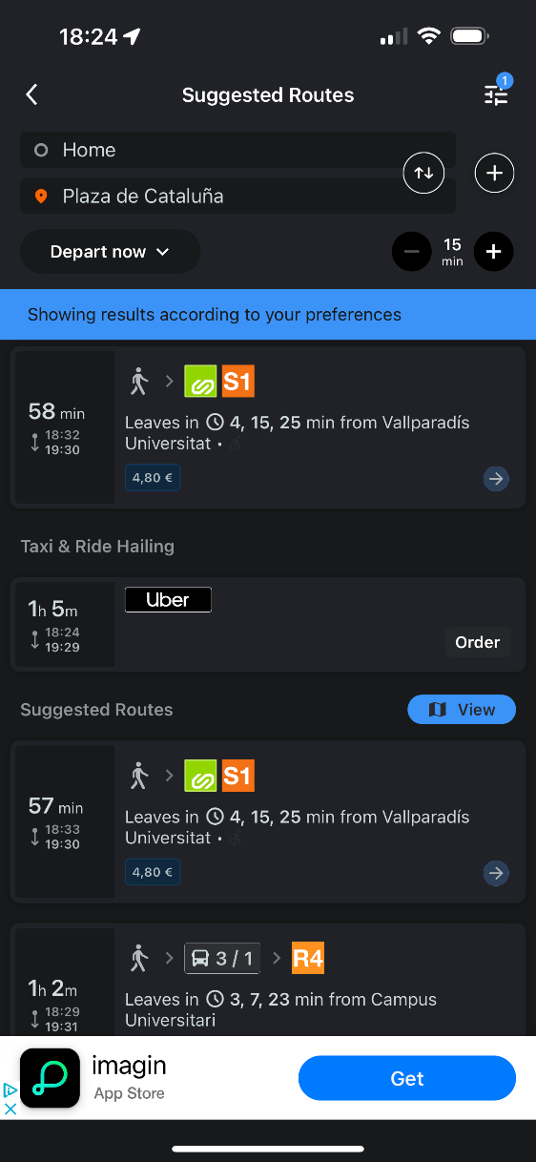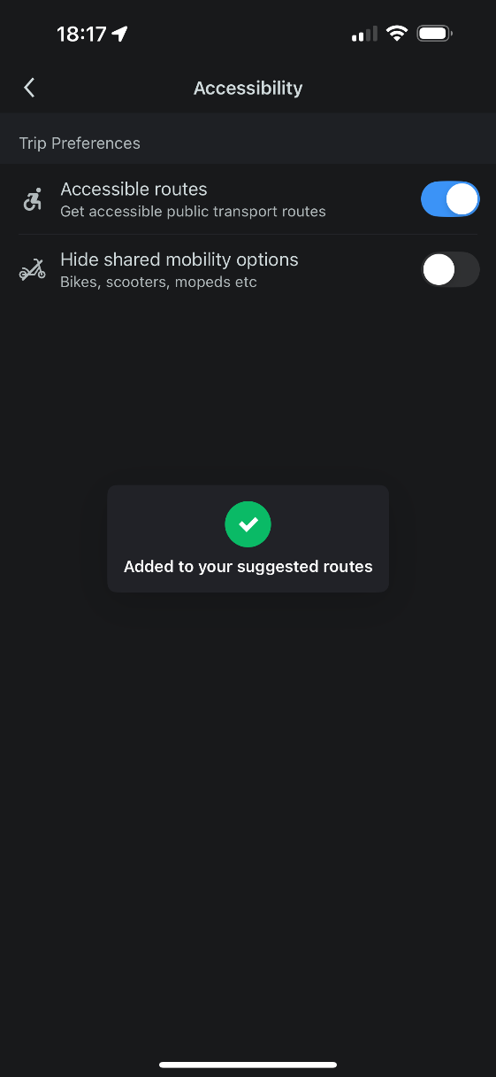**Moovit:*

3️⃣.2️⃣ Flexibility in use

For this principle, I have also chosen the **Google Maps app and its Multiple Input Methods that allow users to search for a destination in different ways.** You can type an address, place the name, you can use voice search by clicking the microphone icon and speaking the request.

**This shows flexibility in use because the app adapts to the different users and situation**s. For example, one user may prefer typing, another regarding physical condition or just preference, might need to use the voice so **Google Maps supports different methods offering multiple ways to perform the same task**.

3️⃣.3️⃣ Simple and intuitive use

To illustrate this principle, I have **chosen Citymapper since it has a very user-friendly and intuitive interface**​. The app uses very clear icons and simple labels for transport options. It also has a simple click "Get Me Home" button to quickly plan a trip to our saved home address. Important information (route options, travel time, cost) is displayed in a clear way, so the user can see the basics immediately.

**All of these make the app simple and intuitive, being easy for users to get directions without needing any help.**

3️⃣.4️⃣ Perceptible information

For this principle, I have chosen the **Citymapper app since it offers the possibility to be used not only by touch but also with voice commands**. So, a user can start the journey by simply asking the voice assistant or clicking on the app. This offers perceptible information in how to use the app because if someone finds it easier to speak or cannot use their hands at that moment, they can still get directions.

By providing the information through text, color and sound the Citymapper app ensures that all users can perceive the information in some way or another.

3️⃣.5️⃣ Tolerance for error

For this principle I have chosen also the **Citymapper “GO” alerts**. This feature provides the possibility to notify users when their stop is approaching, reducing the likelihood of missing the destination.

**So, by alerting the users before the stop, these app prevents the common error of missing a destination demonstrating a design considering the tolerance for error.**

3️⃣.6️⃣ Low physical effort

For this principle I will highlight the **Citymapper “Saved Places” directions accessible through a simple click**. This feature allows users to save their favorite destinations like Home or Work so later, they can get directions to these places with just one click.

Also, **Moovit offers a similar feature that also recognizes commonly input address** and offers the possibility to save it for future usages.

This feature reduces effort, time and the number of steps that a user needs to use the app, allowing fewer steps and easy shortcuts to common addresses **which significantly reduces physical effort while using the app.**

*Citymapper:*

*Moovit:*

3️⃣.7️⃣ Size and space for approach and use

For this principle, I have selected again the example of **the Citymapper interface where we can see Large Icons and Touch Areas on the home screen**. We can see that this app shows big icons with clear labels for transport options like Bus, Metro, FGC, etc. These large touch areas are also called hit targets and in this app are particularly easy to press. We can also observe enough space between the buttons to avoid mistakes and the search options located in a central place in the Home Screen based on the primary usage of the app.

This example shows **the application of the principle of size and space for approach and use because users don´t need to be precise**, the big buttons are easier to press correctly helping people with reduced hand control, tremors and large fingers.

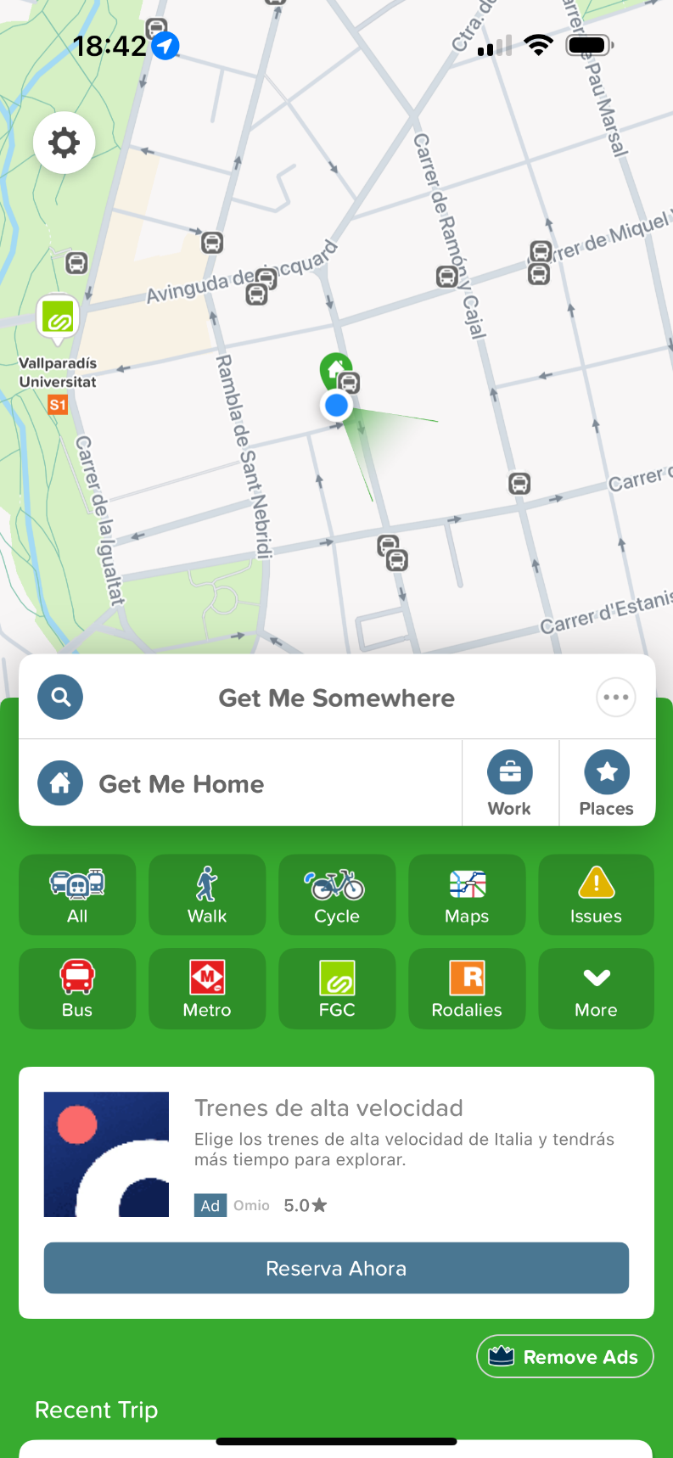

## 4️⃣ First Version of the Prototype

4️⃣.1️⃣ Requirement Chosen I: “**Accessible Route Planning”**

1. **Configure Filters**

**2**

1. **Start Screen**

**1**

**Start Current Location**

**End Let’s go! Where to? 🎙️**

**Route Preferences**

**Find Routes**

**Return Home**

View your alert history

**Recent Alerts**

**3**

**Alert Settings**

Wheelchair Accessible

**Route Preferences**

Customize your route based on your needs**!**

Avoid Stairs

Elevator Required

Limited Mobility

Quiet Routes

Restroom Accessible

Avoid Crowded Areas

**Apply Filters**

**End**

Submit Accessibility Issue report

**Report Accessibility Issue**

**6**

**Submit**

**Cancel**

E.g. The elevator at Plaza Catalunya was …

Describe the issue:

**Report Accessibility Issue**

Help improve accessibility for everyone!

Begin guided navigation

**End**

**Ready to Roll?**

We’ll handle directions from here!

**Not Yet**

**Let’s Go!**

**Navigation Confirmation**

**5**

**Route Details**

**4**

**No Routes Found**

**3b**

**Routes Found**

**3a**

**4**

**2**

**Report Accessibility Issue**

**Your Journey**

Accessible Features:

* No stairs

Accessible Features:

* Low-floor train

Accessible Features:

* Ramp Available

**3a**

**Train S1 to Plaza Catalunya**

**Walk to Destination**

**Walk to Train Station**

**32 min**

2.6 km

**S1**

**Let’s Roll!**

**S1**

**Back to Routes**

**Take a look**

**Take a look**

**R2**

**28 min**

2.1 km

**32 min**

2.6 km

**Adjust Accessibility Filters**

**Hmm, we couldn’t find a match**

Let’s try adjusting your filters to find the best path for you!

In this first requirement prototype I intended to follow the flowchart elaborated in the first exercise but incorporating some minor enhancements like the **Report Accessibility Issue** and **detailed accessibility information for each route**. This interface aims to implement a step-by-step approach in planning accessibility routes aligned with the journey created in the flowchart. In this process I have included some examples of **comprehensive filtering options** that will allow users to customize their journey based on specific accessibility needs and prioritize a friendly communication language with expressions such as *“Ready to Roll?”,* *“Let’s Go!”,* etc.

In this prototype, I show **both scenarios: when you find a route matching the criteria selected and when you need to adjust filters to find a suitable route**. In this design I intended to make the process simple because moving between choosing filters and finding routes can be frustrating, as we saw in the flowchart. My design helps users to quickly switch between screens with buttons that are easy to use like toggle filters, apply filters, and find routes. If no routes match what you need, **the app makes it easy to go back to the filter screen and try new options**. This helps users avoid getting stuck and makes finding accessible routes faster and less annoying.

This prototype presents the same interface for all users with the same interaction patterns avoiding specialized process for accessibility features implementing **Equal Use** in its design. The app ensures that all users, regardless of mobility limitations, plan their routes the same as others. The interface implements also filters like “quiet routes”, “avoid crowded areas” (screen 2) that aims to broaden the scope of accessibility user preferences. The idea was to **avoid stigmatization, segregation while keeping uniform experience for all users**.

Regarding **error toleranc**e, the app aims to handle all the errors in a elegant manner, for example when no routes are found they will gently prompted to adjust the filters. Also, errors like selecting too many filters and creating a very restrictive route search are not crashing the experience and instead guiding the users to revise the inputs with the goal of **preventing frustration and reducing the risk of user abandoning the process** (screen 3b).

I have added also the possibility to cancel at any point of the flow such as cancelling the begin navigation guidance (screen 5) or submitting the accessibility issue (screen 6).

4️⃣.2️⃣ Requirement Chosen II: “**Configurable Alerts”**

1. **Current Alerts Configuration**

**2**

**Start Current Location**

**End Let’s go! Where to? 🎙️**

**Route Preferences**

**Find Routes**

**Alert Settings**

1. **Start Screen**

**1**

**3**



**Send Test Alert**

**Alert Types**

Which types of alerts you want to receive?

Weather Alerts

Accessibility Issues

Service Disruptions

Route Changes

Visual Alerts

Audio Alerts

Haptic Feedback

Advance Notice (min)

**Notification Preferences**

How do you want to receive alerts?

**15**

View your alert history

**Recent Alerts**

**Discard changes**

**Apply Configuration**

**6**

**4**

**5**

**2**

**Test Alert Settings**

**3-1**

**Send Test Notification**

**3-2**

**Sending Test Alert**

A test notification is being sent to your device, please wait …

**Test Alert Settings**

Would you like to send a test notification to verify your settings?

**Yes!**

**Cancel**

**Example Test Alert**

**3-3**

**Service Disruption**

This is a test alert to verify your alerts notification settings.

**Close**

**2**

**⚠️ Service Alert**



You’ll lose all your current changes.

Still want to reset?

Confirm and activate alerts

**Discard All changes**

**5**

**Configured Alerts Activated**

**4-2**

**Settings Saved**

Your alerts preferences have been successfully saved and activated.

**Save Alert Configuration**

**4-1**

**End**

Discard all changes

**End**

**❌ Clear All Changes?**

**Discard Changes**

**Cancel**

**Save Alerts Configuration**

Would you to save and apply your new alert settings?

**Yes!**

**Not yet**

**2**

**Alerts History**

**Resolved**

**All**

**Active**

**1**

**❕**

**❕**

**⚠️**

**Return Home**

**Elevator Out of Service**

The elevator at Plaza Catalunya is

currently out of service.

10 minutes ago

New

**Weather Alert: Heavy Rain**

Heavy rain may affect accessibility.

1 day ago - Resolved

**R13 Rodalies New Service**

New service 11:00 hs. Lleida to

Barcelona since 9 April 2025.

1 hour ago

Search alerts… 🎙️

**Alerts History**

**6**

In this second prototype I have also intended to follow the flowchart created in the first exercise, including all the features described in it and **adding some minor features like browsing the alerts history**.

In this process, and differently from the previous prototype, when selecting preferences, we added pop-up confirmations for applying or discarding changes, aiming at avoiding errors. **Alert settings and preferences have many different options, and if the user changes any configuration by mistake, it may be difficult to recover previous working configurations**, therefore the confirmation steps will implement error tolerance.

We keep **using friendly language aiming at engaging the user with the app** but keeping the formality for the cases I considered is required. We also added an interface where the users can check the alerts history following chronological order, visual status indicators filter options and search functionality.

These **configurable alerts** prototype solution implements **equal use** by using **Multimodal notifications** where users can choose visual, audio or haptic feedback based on their preferences ensuring everyone can perceive the alerts while also, every user configures alerts from the same interface (screen 2).

All alert types are accessible to all the users without restrictions, allowing everyone to benefit from this feature set. (screen 2).

Finally, I will highlight that we have added a **notification time in advance** feature that allows users to set the notification time scoping different user’s preferences. (screen 2).

Regarding **error tolerance** in this interface, we have implemented a test alert where users can send a test notification (screen 3-1 to 3-3) to verify the settings works as expected before saving them. Also, as we described before, the system asks for confirmation before saving changes (screen 4 and 1) preventing accidental changes. We can observe also that the system can discard changes at multiple points in the flow (screen 5 and 2) allowing recovery from mistakes.